Q2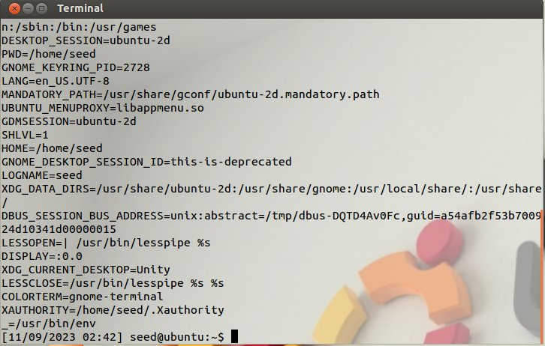

Q3

Ans- Yes it first adds the variable to the current process environment variable then exports it.

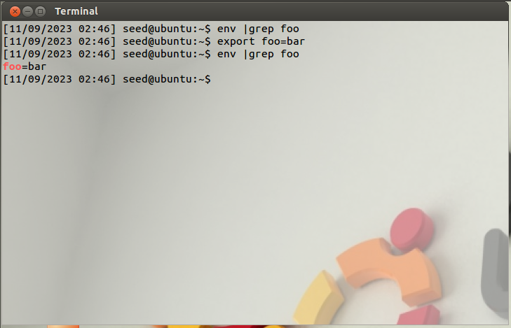

Q4